**COURSEWORK SUBMISSION FORM**

|  |  |  |  |
| --- | --- | --- | --- |
| **STUDENT USE** | | **STAFF USE** | |
| Module Name | Developing Digital Enterprise | First Marker’s  (acts as signature) |  |
| Module Code | **6COSC013C-n** | Second Marker’s  (acts as signature) |  |
| Lecturer Name | Jakhongir Karimov | Agreed Mark |  |
| UoW Student IDs |  | **For Registrar’s office use only (hard copy submission)** | |
| WIUT Student IDs | 00010023 |
| Deadline Date | 24.10.2022 |
| Assignment Type | Individual |
| Word Count | 2384 |

**SUBMISSION INSTRUCTIONS**

**COURSEWORKS *must* be submitted in *both* HARD COPY (to the Registrar’s Office) *and* ELECTRONIC unless instructed otherwise.**

For hardcopy submission instructions refer to: <http://intranet.wiut.uz/Shared%20Documents/Forms/AllItems.aspx> - Coursework hard copy submission instructions.doc

For online submission instructions refer to: <http://intranet.wiut.uz/Shared%20Documents/Forms/AllItems.aspx> - Coursework online submission instructions.doc

|  |
| --- |
| **MARKERS FEEDBACK (Continued on the next page)** |
|  |

**Table of Contents**

Executive Summary 2

Introduction 3

Industrial Market Analysis 4

Internal Business Process Analysis 7

New BIS Development 10

New industrial and internal environment analysis 11

Appendix 12

Reference List 13

**Executive Summary**

The major findings of Macdonald’s stem from its industrial and internal business process environment. According to the Porter’s 5 forces, competitive rivalry, the power of buyers along with the threat of substitutes demonstrate high impact on the company, whereas the power of suppliers remains weak with the threat of new entrants having a moderate effect. Macdonald’s applies its ICT strategies to mitigate these forces by utilizing m-commerce and other online services. Although primary and support value chain activities of the company seem similar to other food industries, Macdonald’s strives to improve them by relying on its e-commerce and free services, such as the presence of Wi-Fi. Automated cash machines could be proposed as a technological innovation. This technology could substitute human work and significantly improve customer experience

**Introduction**

The following report will analyze the McDonald’s company from different perspectives. Some brief overview of the company will be provided initially. Then, external environment of McDonald’s will be analyzed using the Porter’s 5-forces framework. Focus will made on wider effect of ICT on the business environment. There will also be an evaluation of internal environment based on the Porter’s Value chain. Some opportunities of digitalization will be considered that may improve business operations at McDonald’s. After the analysis is complete, new BIS will be suggested that is feasible and can practically be implemented in McDonald’s. Finally, the report will discuss new possible changes in external and internal environment post-implementation of BIS.

In 1954, during his visit to California, Ray Kroc discovered a restaurant that was small, yet very successful. It was run by two brothers Dick and Mac McDonald. Kroc was amazed by the effectiveness of operations, which he attributed to focusing on provision of quality-service and limited product range. The brothers were seeking for a franchising agent and later in the next year, not missing the opportunity, Kroc founded McDonald’s system. Just six years later, he acquired exclusive rights to the name and operating system of McDonald’s. (Origins, [Our History: Ray Kroc & The McDonald's Brothers | McDonald's (mcdonalds.com)](https://www.mcdonalds.com/us/en-us/about-us/our-history.html) )

**Industrial Market Analysis**

This report will analyze industrial market in correspondence with Porter’s 5 forces: Competitive Rivalry, The Power of Buyers, The Power of Suppliers, The Threat of New Entrants and The Threat of Substitutes. Furthermore, the focus will be directed at the way ICT of Macdonald’s affects or can affect all these forces.

**Competitive Rivalry**

Due to the fact that the fast-food industry is highly saturated nowadays, Macdonald’s can experience some challenges when it comes to competition with its rivals. This means that competitive rivalry in the market is very high. According to Sengco (2020), this primarily happens owing to external factors; large numbers of firms, their high levels of aggressiveness and low switching costs contribute to making the fast-food industry competitive. Yet, Macdonald’s utilizes one of its ICT practices which is based on m-commerce. For convenience purposes, not only does the business rely on its online website, but it also has its own mobile application which comes in handy while ordering food. Food ordering via cell phones makes customers spend more money and visit a certain food restaurant more often (Samantha, 2017). This, in turn, can demonstrate high competitiveness compared to those rivals which have not yet introduced m-commerce.

**The Power of Buyers**

The bargaining power of buyers is also very high. Macdonald’s, as a result, should always address the influence of its customers along with their demands. Once again, it is external factors that mainly make the power of buyers quite influential, which are great availability of substitutes, huge number of providers and low switching costs. As a consequence, it is easy for customers to switch to other food businesses. Customers show high sensitivity to price when it is simple to find similar food restaurants. (Jones, 2021). For this reason, to mitigate the demands of buyers, Macdonald’s uses some of its own innovations. As an illustration, using the online website customers can find out a rewarding system (Refer to Appendix 1). Whenever a person orders food, he or she is then offered the bonus which is based on scoring points. With the scored points, customers can buy fast food without a need to pay. This ICT application makes company quite interesting, as more and more people would be interested in purchasing products in terms of rewarded system.

**The Power of Suppliers**

The bargaining power of suppliers, however, turns out to be weak. There are three reasons causing this: huge number of suppliers, low forward vertical integration and high overall supply. It appears that most suppliers in fast-food industry lack local or global alliances. It is also difficult for suppliers to impact Macdonald’s due to the lack of control over the distribution network associated with the company. Likewise, redundant products, such as meat or flour decreases supplier’s impact on the company. Macdonald’s seems to be aware of its suppliers’ weaknesses since the main products the company uses are chicken and beverages. For this reason, the use of ICT is not even considered.

**The Threat of Substitutes**

Substitutes pose a great threat to Macdonald’s. There is always high volume of alternatives available, low switching costs and high performance-to-cost ratio. Macdonald’s products can be substituted by products ranging from artisanal food producers to regional bakeries. Moreover, it should be noted that people can also prepare food at home. Although there are numerous options for people when it comes to food, there are still those who are concerned about their expenditures. One of the best ICT applications and innovations that company uses is the creation of Dollar Value Menu. This is a specific menu (1$ 2$ 3$ Dollar Menu) where certain products, including chicken and beverages can be bought for reasonable price. The service can be found online both on the website and mobile application (Refer to Appendix 2). With the availability of cheap offers, Macdonald’s can attract more customers who would be more willing to order foods on a regular basis.

**The Threat of New Entrants**

The threat of new entrants can be divided into international and local scopes. On international scale, it is quite difficult for companies to enter the market with existing popular competitors, like Macdonald’s. There is a need for high investment for food production, leaving the part of digitalization. However, on a local scale where there is no need for high investment, the entry barrier is low, as 3-4 outlets are enough considering an easy establishment of economies of scale. Overall, it can be stated that the threat of new entrants is moderate To tackle a possible issue with new entrants, Macdonald’s has established a good connection with community which can be accessed and on the Internet. The website, apart from providing services, has its own community sections (Refer to Appendix 3). All of these indicate that the company has a strong customer loyalty which is difficult for new food industries to establish in the beginning.

**Internal Business Process Analysis**

The internal business process or value chain of Macdonald’s will be provided according to both primary and support activities. The analysis will be done according to the report written by Nikhil (2020).

**Primary Activities Support Activities**

**Inbound Logistics**

Macdonald’s acquires all its raw materials exclusively from its pre-defined suppliers. This helps to increase labor, capital and production. The ICT in inbound logistics is applied in accordance with the system pf backward vertical integration. (Refer to Appendix 4). This is primarily done to reduce the number of suppliers and contributes to reduction of costs and ensures high quality of products.

**Operations**

Macdonald’s operations can be characterized by its establishment of the distribution network needed for mass-production. The warehouse stores a variety of products, including paper materials, foods as well as cleaning supplies. Therefore, both warehousing and distribution is rather centralized than done manually. When it comes to ICT, some of the operations depend on the use of automation. This means that there is a procedure that a computer follows to keep track of what is needed to be shipped or distributed which gives signal to distribution centers to make proper schedule of items delivery.

**Outbound Logistics**

As regards outbound logistics, the main focus is directed at energy conservation, sustainable packaging and waste management. Macdonald’s proves to be highly innovative in this value chain to make its business even more profitable and environmentally friendly. The company constantly updates its menu options, puts efforts to improve customer experience and tries to broaden accessibility to the brand. The availability of m-commerce and other ICT practices mentioned above, such as Dollar Value Menu are prime examples of this.

**Marketing and Advertising**

Over the pas few decades, Macdonald’s has successfully maintained its recognized advertising strategy. Not only do advertising campaign include the use of media, like TVs, radio and newspapers, but it also extensively utilizes billboards and signage. The company also sponsors sports events and makes coolers of orange drink symbolizing its logo. Apart from this, television has always played a key role in advertising. Now, with the availability of e-commerce and m-commerce, customers can also access entertainment pages related to articles, history and other services provided.

**After Sales Services**

After food has been ordered, there are a number of ways customers could utilize Macdonald’s available services. First of all, everybody can easily access Wi-Fi using their laptops or mobile phones for free. Customer can also buy special Arch Cards which would be convenient for making further purchases. Employees should also be taken into account. For a well-done job, staff member can obtain special Macdonald’s Certificates which can retain and encourage staff to work harder.

**Firm Infrastructure**

Macdonald’s infrastructure has become quite strong with a number of innovations established as well as the integration of modern technology. One of the best practices which positively affected the infrastructure was the introduction of green activities which can be read on the website. This integration highlights the eco-friendliness of the company. For example, the company was able to reduce energy over the past 5 years. It also put efforts toward recycling process which helped to achieve success in terms of remaining eco-friendly.

**Human Resources Management**

Although management partly understands that most of the employees work in the company for a short-time period, there are still some strategies which ensure that staff members are motivated to stay. For instance, as it was mentioned earlier, the company praises its workforce by providing special gifts or certificates. The free access to Wi-Fi could also positively influence the mood of staff. The company also strives to provide best work conditions for its members by providing flexible hours and free meals.

**Technology**

Macdonald’s constantly strives to modernize its restaurant, evolve menu offers and bring engineering value. This statement can be exemplified by the fact that during the pandemic in 2019, Macdonald’s was proclaimed as the winner of its business continuation via digital innovations for its core customers. Ordering food and payment accomplished with the use of cell phones and the integration of self-order kiosks positively influenced customer experience which allowed to make secure purchases and personalize their order depending on their needs (Campos, 2021).

**Procurement**

With reference to procurement, Macdonald’s utilizes its e-business. This means that the company utilizes E-Procurement System which proves to be quite efficient in terms of providing the backbone both for the logistics and the whole supply management chain. The procurement hub which was developed in 2001 allows the company’s franchises all over the world to acquire different materials needed to run their businesses. E-Procurement also allows some business owners to purchase supplies and needed products at a discounted price.

**New BIS Development**

It is common knowledge that when the topic concerns food restaurants, ordering food is mainly done by approaching to a cashier. The outbreak of Covid-19 was an indication for food industries to commence online operations, which was successfully practiced by many food restaurants, including Macdonald’s. Yet, there still were those companies who employed cashiers during the pandemic after considering safety measures, such as wearing masks. Given that some companies were able to continue operating online, there is a high chance that this could bring new innovative ideas attributed to human substitution.

As a business development plan, my idea is to introduce automated machines accounting for the jobs performed by cashiers. In other words, customers will be able to order food without the need for meeting staff members face-to-face. According to the journalist Pereira (2022), cashiers working in some food companies with a high workload cannot manually manage and serve every single customer on time. For this reason, the idea of automated cash system could replace the main function of operations in Macdonald’s. People will simply select their preferred meal by clicking and swiping a screen to make a purchase.

**New industrial and internal environment analysis**

The integration of automated cash machines which would substitute manual work could be advantageous for Macdonald’s in many ways. To begin with, the company will no longer need cashiers which would in turn bring profits. This innovation could also enhance the customer experience. With fast automated machines, customers would not need to wait much staying in the queue and waiting. This will, in turn, ensure that bottlenecks are avoided, and less people would feel stressful.

The substitution of cashiers could also be helpful for industrial and internal environment. It would, first of all, affect the power of buyers, the threat of new entrants and substitutes and competitive rivalry. Being aware of automated system, people would be more attracted to the services where there will be no need to hurry while selecting food. This technological advancement would, in turn, pose difficulties for new food industries to enter the market and for existing rivals, as the automated system would make Macdonald’s stand out from the crowd.

When it comes to operation activities, the overall workflow would be handled with a relative ease, since as it was mentioned above, there would be less bottlenecks. This innovation could then be heavily advertised across the globe to attract public attention. Support activities, including human resources management and technology would benefit the most. There would be no need to worry about recruiting cashiers in case some of them decide to quit. Overall, Macdonald’s could become more autonomous new technological innovations entering its spectrum.

**Appendix**

Appendix 1

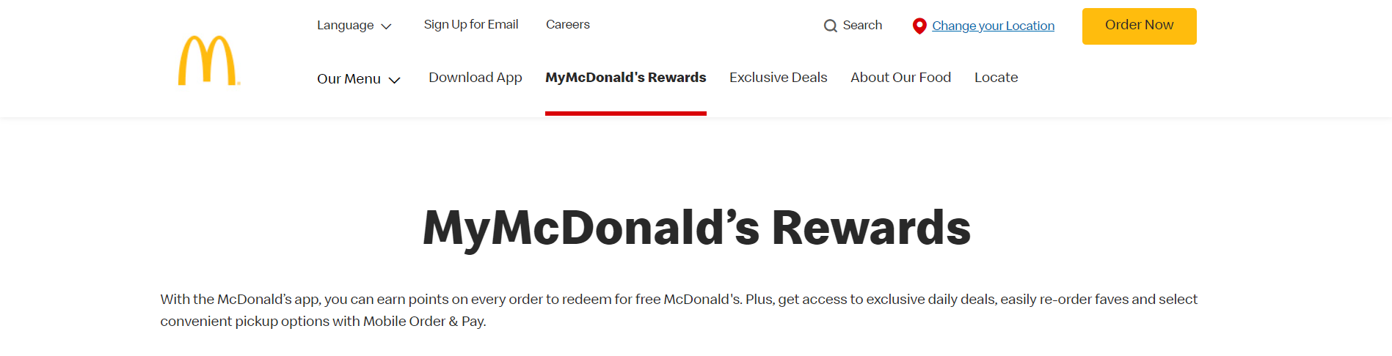

Appendix 2

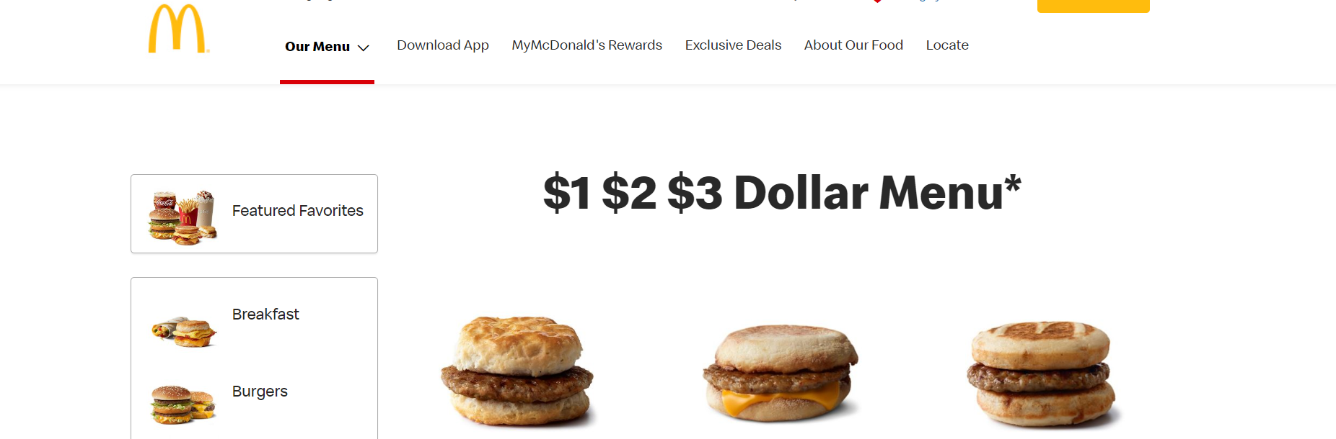

Appendix 3

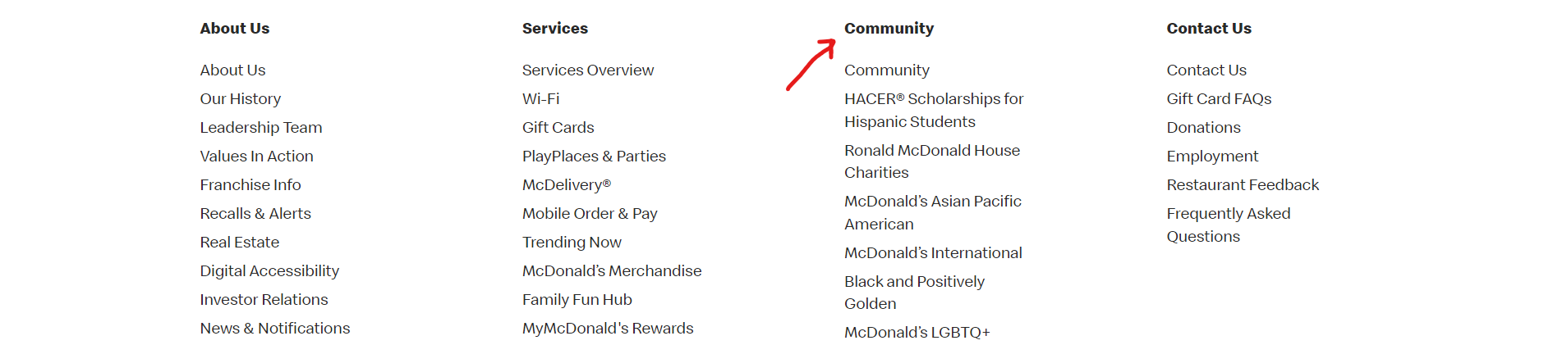

Appendix 4 (Source: <https://learnbusinessconcepts.com/vertical-integration-real-examples-in-the-united-states> )

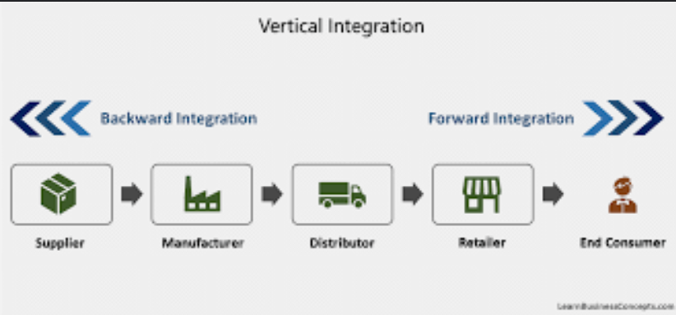

**Reference List**

# Bompcamp, S. (2016). Why restaurants want you to order food on your phone. Available from <https://phys.org/news/2016-09-restaurants-food.html> [Accessed 22 October 2022]

# Campos, D. (2021). Committing to the Core: How McDonald’s Innovated to Survive (and Thrive) During the COVID-19 Pandemic. *Digital Innovation and Transformation*. Available from <https://d3.harvard.edu/platform-digit/submission/committing-to-the-core-how-mcdonalds-innovated-to-survive-and-thrive-during-the-covid-19-pandemic/> [Accessed 23 October 2022]

# Jones, P. (2021). Price your food product with consumer behavior in mind, part 1. *Michigan State University*. Available from <https://www.canr.msu.edu/news/price-your-food-product-with-consumer-behavior-in-mind-part-1> [Accessed 21 October 2022]

# Nikhil, B. (2022). McDonald's Value Chain Model. Available from <https://www.academia.edu/22004170/McDonalds_Value_Chain_Model> [Accessed 23 October 2022]

Macdonald’s. Available from <https://www.mcdonalds.com/us/en-us.html> [Accessed 20 October 2022]

# Pereira, S. (2022). Self-checkout systems create headaches for cashiers. *Economy and Workers’ Rights*. Available from <https://prismreports.org/2022/05/24/self-checkout-system-headaches-for-cashiers/> [Accessed 24 October 2022]

# Sengco, L. (2022). McDonald's Five Forces Analysis. Available from <https://www.academia.edu/31196735/McDonalds_Five_Forces_Analysis_PORTERS_MODEL> [Accessed 21 October 2022]